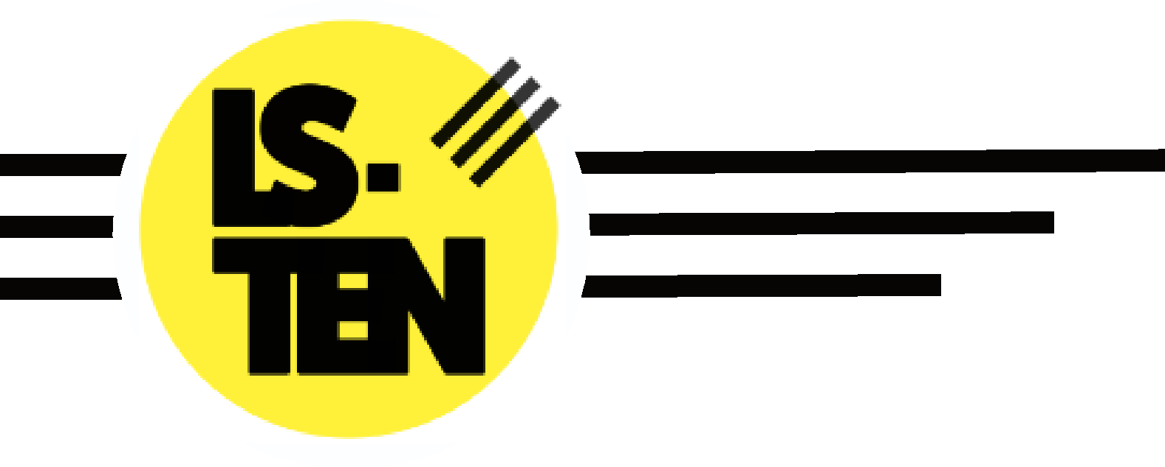

Managing Medications Policy

Issued by:
Carl Harrison (Chief Executive Officer)

Issue Date: 01/09/2020

 | Last Review | Review due
Executive: | 01/02/2023 | 01/02/2024
Governance: | 15/05/2023 | 15/05/2024

- Aims

Our aim at LS-TEN is to provide all learners, with any medical conditions, the same opportunities as others in their education. We will help to ensure they can:
  - be healthy
  - stay safe
  - enjoy and achieve
  - make a positive contribution
  - achieve economic well-being.

- Rationale

It is our view at LS-TEN that medicines should only be brought into the facility when essential; that is where it would be detrimental to a young person’s health if the medicine were not administered during the provision’s hours.
Wherever possible (which is in most cases) medicines should be prescribed in dose frequencies which enable them to be taken outside school hours. Parents/carers are encouraged to ask the prescriber about this. It is noted that where medicines need to be taken three times a day, this could be done before and after school, and at bedtime.

- Role of the Education Leadership Team

The Education Leadership Team have responsibility for implementing the policy and procedures for dealing with medical needs and will make sure all parents are aware of this policy at the time of admission, through referral and other meetings, and via LS-TEN’s website.
The Education Leadership Team (ELT) will ensure that suitable training and support is offered to team members, identified as supporting learners with medical conditions, provided by appropriate healthcare professionals.
The ELT will, where parents/carers expectations appear unreasonable, seek advice from the host school’s nurse or doctor or other medication adviser, as appropriate. The ELT will ensure that attention is paid to the safe storage, handling and disposal of medicines.

- Role of Tutors and Support Staff

Team members who have a learner with medical needs under their supervision will be told of the nature of the condition and as to when the learner may need extra attention. They will also be made aware of what action should be taken if an emergency should arise.
All curriculum activities will be risk assessed appropriate to their medical needs. Any volunteer and wider team members will be made aware of the medical needs of individual learners, where appropriate. At different times during the learning day other staff may be responsible for the students (e.g. Skatepark team members). They too will be informed, where appropriate.

- Role of the Parent/Carers

Parents/carers are responsible for making sure that the child in their care is well enough to attend the provision in the first instance. Parents/carers are also responsible for informing the host school, their child’s medical condition and/or needs. The host school is then required to pass this information to LS-TEN through the young person’s referral paperwork and initial meetings.

Parents/carers should keep children at home when they are acutely unwell – guidance from the Health Protection Agency advises children who are suffering from sickness and diarrhoea should be kept away from school settings for 48 hours from the last episode of diarrhoea or vomiting and should be excluded from swimming for 2 weeks following last episode of diarrhoea.

It is the parent/carer’s responsibility to inform LS-TEN of any medical condition that could impact on the learner’s health and safety welfare, behaviour etc. during the school day, either at the time of the young person’s admission to the provision or when a medical condition develops. Where necessary, parents/carers will be asked to provide LS-TEN with sufficient written information about their child’s medical needs. All information received will be treated with the utmost confidentiality.

It is the parent/carer’s responsibility to ensure any medication required to be kept at LS-TEN is collected and replaced when use by date has expired e.g. epipens, inhalers.

- LS-TEN Staff Administering Medication

LS-TEN’s conditions of employment do not include giving medication or supervising a learner taking it. LS-TEN has a number of designated first aid officers, among the Support Team, who are not medically trained but are available to supervise/administer medication during the school day.

There is no legal duty that requires staff to administer medicines. However, any team member who agrees to accept responsibility for administering on-going/life sustaining prescribed medication to a learner will have proper training and guidance if required. The type of training will depend on each individual case and the advice of the host school’s associated medical professional.

LS-TEN will not accept any medicines: without written parental/carer consent; that have been taken out of the container as originally dispensed; or make changes to dosages on parental/carer instructions.

- Learners

LS-TEN will support and encourage learners, in consultation with their parents/carers and the host school, who are able to take responsibility for managing their own medicines. For those learners considered to be disabled and/or with special educational needs who have a medical condition, provision detailed within the health section of their Education, Health and Care (EHC) plan will be used in line with:
Special Educational Needs and Disability (SEND) Code of Practice;
Disability Discrimination Act 1995;
and Equality Act 2010.

Learners with a long-term illness should, whenever possible, assume complete responsibility, under the supervision of their parent/carer, for managing their own medicines.

Learners should know where their own medicines are stored and who holds the key. Learners are allowed to carry their own inhalers where appropriate, with spares kept in the medical cupboard. If a young person refuses to take medicine, LS-TEN team members will not force them to do so, but instead will note this on the learner record and follow agreed procedures on their Individual Risk Assessment (if applicable).

Parents/carers will be informed by telephone message of any refusal as soon as possible and always on the same day.

- Short-Term Medical Needs

Many young people will need to take medication or be given it at some time during their education. Generally this will be for a short period only e.g. to finish a course of antibiotics or apply a lotion. Where it is necessary for medication to be administered, parents/carers will be encouraged to ask the prescribing doctor or dentist to prescribe dose frequencies that enable it to be taken outside school hours.

- Long-Term Medical Needs

It is essential that the provision has sufficient information about the medical condition of any learner with long-term medical needs, this may need to be in the form of an Individual Health Care Plan – see item 13.
The following information is required:
- Details of the condition
- Special requirements (dietary, pre-activity precautions etc.)
- Medication and any side effects
- What to do and who to contact in an emergency
- The role LS-TEN plays

- Educational Visits and Sporting Activities

On occasions the provision may need to take additional measures for outside visits and/or sporting activities, for which consent will be obtained in advance of the activity. Parents/carers should inform LS-TEN if their child is to be involved in either of the above and has any medical needs, together with any relevant emergency procedures. LS-TEN encourages and supports all learners irrespective of medical needs to participate as much as possible in the life of the provision.

- Emergency Procedures

If a learner needs to be taken to hospital in an ambulance, a parent/carer will be required to accompany their child to hospital. In the event that a parent/carer does not arrive in time for the ambulance to depart, the pupil is to be accompanied by a member of staff who will stay with pupil until parent/carer arrives. Relevant medical/medication information will be taken, as appropriate. Guidance stipulates that staff should never take students to hospital in their own car and the school supports this.

- Individual Health Care Plans (IHCP)

Some learners have medical conditions, either short-term or long-term, that if not properly managed could limit their access to education. In such cases it may be necessary to provide an IHCP which will ensure that team members have sufficient information to understand and support a young person with long-term medical needs. In this instance the host school will complete an IHCP in conjunction with the parent/carer and the appropriate health care professional for the learner which will be shared with LS-TEN and updated to suit the learner’s education within our provision. Where learners have life threatening conditions, specific IHCPs should be carried on vehicles to and from LS-TEN. IHCPs are to be reviewed annually or if any changes occur to condition and/or treatment, to be initiated by Parents/Carers in conjunction with their appropriate Medical Professional and First Aider.

- Storing Medicines

Large volumes of medicines will not be stored at LS-TEN. Team members will only store, supervise and administer medicine that has been prescribed for an individual learner. Team members should never give a non-prescribed medicine to a learner unless there is specific prior written permission from the parents/carers.

Form 1 is required to be completed by a parent/carer and handed in to the office with the medication.

The Education Leadership Team will also be required to complete Form 2 agreeing to administer the medication in the provision.

A child under 16 should never be given medicine containing aspirin unless prescribed by a doctor and parents/carers have given written consent. LS-TEN will not administer Ibuprofen to children under 12 unless prescribed by a doctor and parents/carers have given written consent. Medicines will be stored strictly in accordance with product instructions and in the original container as dispensed by the pharmacist.

FORM 1 Request for LS-TEN to administer medication

LS-TEN will not give the child in your care medication unless you complete and sign this form, and a member of the Education Leadership Team has agreed that LS-TEN can administer the medication. A child under 16 should never be given aspirin unless prescribed by a doctor.

Learner Name: | Learner DOB:
Address

Condition/illness medication to be issued for:
Medication - Note: All medicines must be in the original container.
Name/Type of medication and strength:

For how long will your child take this medication (start and end date required):

Date dispensed:
Quantity received:
Full directions for use:

Amount of medication to be taken and method of administration:

Timing:

Special precautions:

Are there any side effects LS-TEN need to know about?

Self-administration | Yes / No (please circle appropriate answer)
Procedures to take in an emergency:

Contact Details
Name: | Telephone number:
Address:

I understand that I must deliver the medicine personally to a member of the Education Leadership Team, and accept that this is a service which LS-TEN is not obliged to undertake. I understand that I must notify LS-TEN of any changes in writing.
Signature(s)

Date:
Relationship to Learner:

FORM 2 - Confirmation of LS-TEN’s agreement to administer medication
To be authorised be a member of the Education Leadership Team

Learner Name:

I agree that (name of leaner) will receive (quantity and name of medication) every day at (time medicine to be administered e.g. lunchtime or afternoon break).

(Name of learner) will be given/supervised whilst he/she takes their medication by a member of the first aid team.

This arrangement will continue until (either end date of course of medicine or until instructed by parents/carers).

Signed:
(Director of Education / Deputy Head of Education / Named Member of staff)

Date:

