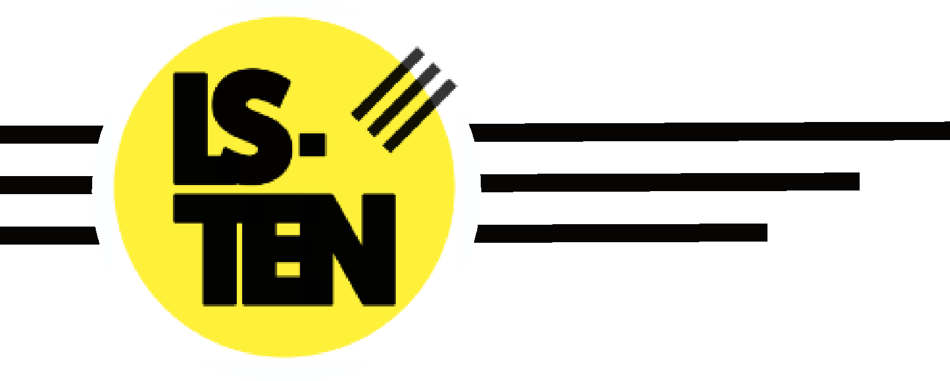

Political Indoctrination & Visitor Speaking Policy
Issued by: Darren Reddyhoff (Head of Education, DSL)

 | Last Review | Review due
Executive: | 01/08/2022 | 01/08/2023

Introduction
This policy should be read in conjunction with our Child Protection and Safeguarding Policy.
Independent schools must meet the Spiritual, Moral, Social and Cultural (SMSC) development standard set out in the Education (Independent School Standards) (England) Regulations 2014. A commitment to make changes to strengthen the SMSC standard was included in the Government’s Prevent strategy to ensure that schools:

- encourage pupils to respect specified fundamental British values;
- do not promote extremist views, or partisan political views, through their curriculum and/or teaching, and
- offer pupils a balanced presentation of views when political issues are brought to their attention.

The following definitions drawn from DfE Advice for Improving the Spiritual, Moral, Social and Cultural Development of Pupils are referred to in this policy:

- Partisan - in a case relating to the alleged promotion of partisan political views in maintained schools1 the judge considered that the best synonym for "partisan" was "onesided".

- Political views – views expressed for a political purpose

- A political purpose is either directly or indirectly:
  - to further the interests of a particular political party; or
  - to procure changes to the laws of this or another country; or
  - to procure the reversal of government policy or of particular decisions of governmental authorities in this or another country.

The Education (Independent School Standards) Regulations 2014

The Education (Independent School Standards) Regulations 2014 details how the spiritual, moral, social and cultural development of pupils are met by:

(a) actively promoting the fundamental British values of democracy, the rule of law, individual liberty, and mutual respect and tolerance of those with different faiths and beliefs;

(b) ensuring that principles are actively promoted which:

- enable pupils to develop their self-knowledge, self-esteem and self-confidence;
- enable pupils to distinguish right from wrong and to respect the civil and criminal law of England;
- encourage pupils to accept responsibility for their behaviour, show initiative and understand how they can contribute positively to the lives of those living and working in the locality in which the school is situated and to society more widely;
- enable pupils to acquire a broad general knowledge of and respect for public institutions and services in England;
- further tolerance and harmony between different cultural traditions by enabling pupils to acquire an appreciation of and respect for their own and other cultures;
- encourage respect for other people, paying particular regard to the protected characteristics set out in the Equality 2010 Act; and
- encourage respect for democracy and support for participation in the democratic process, including respect for the basis on which the law is made and applied in England;

(c) precluding the promotion of partisan political views in the teaching of any subject in the school; and

(d) taking such steps as are reasonably practicable to ensure that where political issues are brought to the attention of pupils:

- while they are in attendance at the school,
- while they are taking part in extra-curricular activities which are provided or organised by or on behalf of the school, or
- in the promotion at the school, including through the distribution of promotional material, of extra-curricular activities taking place at the school or elsewhere, they are offered a balanced presentation of opposing views.

Improving the Spiritual, Moral, Social and Cultural Development of Pupils

Guidance given by the Department for Education (DfE) for Improving the Spiritual, Moral, Social and Cultural (SMSC) Development of Pupils, details how political views are handled. The standard for SMSC is to prevent the political indoctrination of pupils through the curriculum.

The aim is not to prevent pupils from being exposed to political views or from discussing political issues in school but pupils should not be actively encouraged by teachers or others to support particular political viewpoints.

Concepts such as democracy and the historical development of the political process in society cannot be meaningfully taught without reference to political belief and practice, and the use of concrete examples is normally helpful in promoting understanding. Teaching staff will not exploit pupils’ vulnerability by seeking to convince them that a particular political position is necessarily correct, or by trying to impose their own views on pupils. Such action may amount to a breach of Part 2 of the Teachers’ Standards on personal and professional conduct, in particular:

- not undermining fundamental British values, including democracy, the rule of law, individual liberty and mutual respect, and tolerance of those with different faiths and beliefs

- ensuring that personal beliefs are not expressed in ways which exploit pupils’ vulnerability or might lead them to break the law.

LS-TEN will ensure that teachers are aware of the Professional Standards applying to them.

Although LS-TEN does not preclude the presentation of controversial political viewpoints to pupils, schools and individual teachers should ensure that views are not promoted which are inconsistent with the requirements of any other part of the SMSC development of pupils (for example views which are derogatory of particular ethnic groups or faiths, or which are actively in opposition to the fundamental British values).

If a member of staff wishes to use an external speaker to talk to the pupils, the school will vet them in case they hold views which go against the requirements of any part of the SMSC standard, and if still used, the school will ensure that the content of their presentation is agreed beforehand. See Appendix 1 and 2 for detailed guidance.
