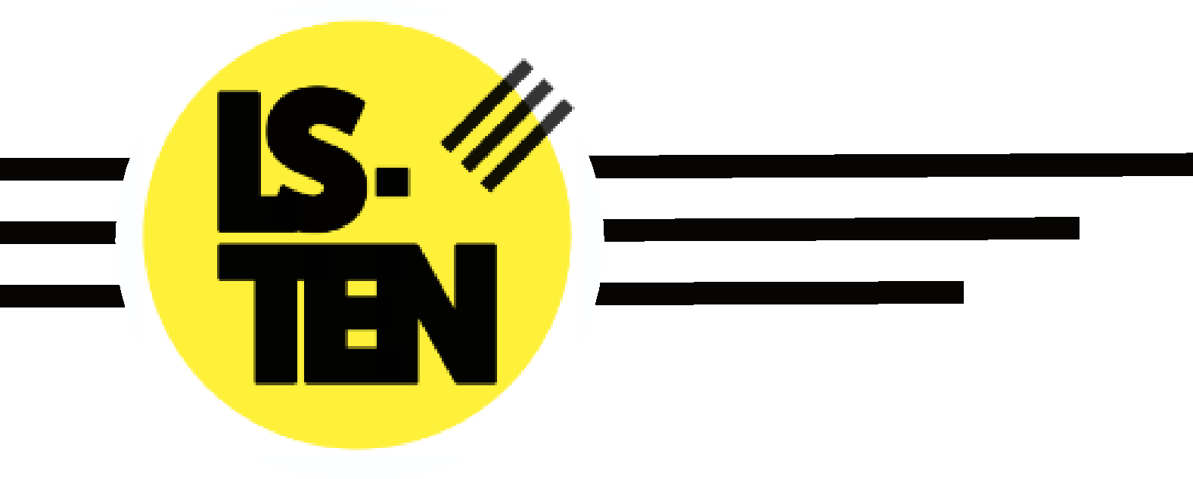

Accessibility Plan

Issued by: Amy Harrison (Business Manager)

Issue Date: 01/09/2020
Last Review Date: 18/01/2023
Next Review Date: 01/07/2023

Contents:

Aims of the Accessibility Plan

- The accessibility audit
- Planning duty 1: Curriculum
- Planning duty 2: Physical environment
- Planning duty 3: Information

Aims of the Accessibility Plan

This plan outlines how LS-TEN aims to increase access to education for pupils with disabilities in the three areas required by the planning duties in the Equality Act 2010 (i.e. the curriculum, physical environment and information).

A person is regarded as having a disability under the Act where they have a physical or mental impairment that has a substantial and long-term adverse effect on their ability to carry out normal day-to-day activities.

This plan aims to:
- Increase the extent to which pupils with disabilities can participate in the curriculum.
- Improve the physical environment of the school to enable pupils with disabilities to take better advantage of education, benefits, facilities and services provided.
- Improve the availability of accessible information to pupils with disabilities.

The above aims will be delivered within a reasonable timeframe, and in ways which are determined after taking into account pupils’ disabilities and the views of parents and pupils. In the preparation of an accessibility strategy, the LA must have regard to the need to allocate adequate resources in the implementation of this strategy.
The governing board also recognises its responsibilities towards employees with disabilities and will:
- Monitor recruitment procedures to ensure that individuals with disabilities are provided with equal opportunities.
- Provide appropriate support and provision for employees with disabilities to ensure that they can carry out their work effectively without barriers.
- Undertake reasonable adjustments to enable staff to access the workplace.
The plan will be resourced, implemented, reviewed and revised in consultation with:
- Pupils’ parents/carers
- The CEO, Head of Education and other relevant members of staff.
- Governors.
- External partners, including roll schools

This plan is reviewed every year to take into account the changing needs of the school and its pupils. The plan is also reviewed where the school has undergone a refurbishment.

The Accessibility Audit

The School Leadership inclusive of the executive and governance will undertake an annual Accessibility Audit. The audit will cover the following three areas:

- Access to the curriculum – the board will assess the extent to which pupils with disabilities can access the curriculum on an equal basis with their peers.
- Access to the physical environment – the board will assess the extent to which pupils with disabilities can access the physical environment on an equal basis with their peers.
- Access to information – the board will assess the extent to which pupils with disabilities can access information on an equal basis with their peers.

When conducting the audit, all kinds of disabilities and impairments will be considered, including, but not limited to, the following:

- Ambulatory disabilities – this includes pupils who use a wheelchair or mobility aid
- Dexterity disabilities – this includes those whose everyday manual handling of objects and fixtures may be impaired
- Visual disabilities – this includes those with visual impairments and sensitivities
- Auditory disabilities – this includes those with hearing impairments and sensitivities
- Comprehension – this includes hidden disabilities, such as autism and dyslexia

The findings from the audit will be used to identify short-, medium- and long-term actions to address specific gaps and improve access.

All actions will be carried out in a reasonable timeframe, and after taking into account pupils’ disabilities and the preferences of their parents. The actions that will be undertaken are detailed in the following sections of this document.

Planning duty 1: Curriculum

 | Issue | What | Who | When | Outcome | Review
Short term | Staff members do not know whether the curriculum is accessible | Audit of the curriculum | Head of Education, teachers, SENCO / Director of Education | January 2023 | Management and teaching staff are aware of the accessibility gaps in the curriculum –  Curriculum is tailored to learning following baseline and ongoing assessment | Summer 2023
 | Staff members do not have the skills to support pupils with SEND | INSET provided to staff members  Training for teachers on differentiating the curriculum | Director of Education, external advisors, SENCO | January 2023 | Staff members have the skills to support pupils with SEND – addressed through;  Access training packages online and in person  Trauma informed practice training | Summer  2023
Medium term | School trips do not take into account pupils with SEND | Needs of pupils with SEND are incorporated into the planning process | Teachers, SENCO | January 2023 | Planning of school trips takes into account pupils with SEND  Reviewed on a case by case basis  Informed by EHCPs | Summer  2023
Long term | Pupils with SEND cannot access lessons | Provide tablets / electronic notepads and other adjustments for pupils with SEND  Electronic remote learning, bespoke 121 and 2 to 1 learning  Twilight session / amended timetable  Time out spaces available | Head of Education, CEO, SENCO | Summer 2022 | Pupils with SEND can access lessons | Summer 2023

Planning duty 2: Physical environment

 | Issue | What | Who | When | Outcome | Review
Short term | Management does not know if the school’s physical environment is accessible | Audit of physical environment | CEO, H&S Lead, Business Manager and Landlords | Summer 2022 | School is aware of accessibility barriers to its physical environment and will make a plan to address them  Classrooms rotated / lift repaired maintained regularly  Listening to the dynamic needs of learners | January 2023  May 2023  July 2023
Medium term | Learning environment of pupils with visual impairments is not accessible | Incorporation of appropriate colour schemes  Display screens  Seating arrangements  Lighting  Handouts and resources – colours, fonts  Liaison with home to ensure visual aids are brought to school | Head of Education, CEO | Summer 2022 | Learning environment is accessible to pupils with visual impairments | January 2023
 | Learning environment on the first floor | Lift access into Education space needs regular service. | CEO, H&S Manager | Summer 2022 | Lift access to the education space uninterrupted. | January 2023
Long term | Children with physical disabilities have limited access to skatepark use. | Introduce additional disability friendly equipment and modify ramps internally and externally.  Adapted bikes available, pads and protective gear  Coaches trained in working with those with disabilities | CEO, H&S Manager and building contractors | Summer 2022 | Skatepark is fully accessible | Summer 2023

Planning duty 3: Information

 | Issue | What | Who | When | Outcome | Review
Short term | Management staff do not know whether school information is accessible or not | Audit of information and delivery procedures | COO, Business Manager, CEO, Director Of Education | Summer 2022 | School is aware of accessibility gaps to its information delivery procedures  Website | Summer 2023
 | School does not know how to make written information accessible | Schools seeks advice from external advisors including Scope. | COO, Business Manager, CEO, Director Of Education | Summer 2022 | School is aware of local services for converting written information into alternative formats  EAL / Scope links  (Hamara) | Summer 2023
Medium term | Written information is not accessible to pupils with visual impairments | Provide written information in alternative formats  Incorporate appropriate colour schemes when refurbishing and install window blinds | COO, Business Manager, CEO, Director Of Education | Summer 2022 | Written information is fully accessible to children with visual impairments | Summer 2023
Long term | School website is not accessible to children with SEND | Audit of website | COO, Business Manager | Summer 2022 | Website is fully accessible | Summer 2023

